做智慧人

在2025年伊始，相信有許多弟兄姐妹都有新年立志（New Year Resolution），希望你的新年計劃中包括了每天的讀經禱告，抓住一切機會傳福音。保羅給以弗所教會的勸勉可以作為我們最好的新年立志*：「你們要謹慎行事, 不要像愚昧人，當像智慧人。要愛惜光陰，因為現今的世代邪惡。不要作糊塗人，要明白主的旨意如何」*(弗5:15-17)。讓我們在新的一年裡，靠着神的恩典每天能夠謹慎行事, 愛惜光陰 , 明白神在我們身上的旨意，努力做個忠心，良善且有見識神的僕人！

# **感恩**

1. 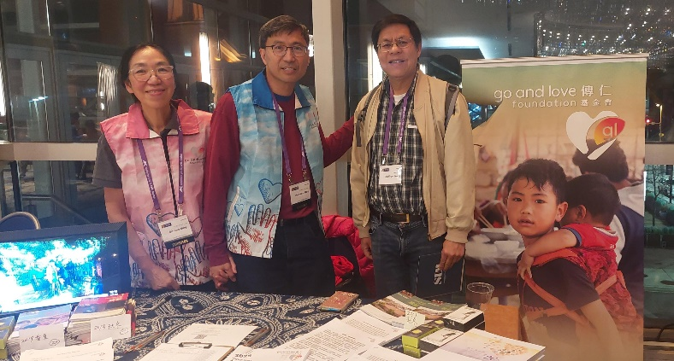新同工梅漢煒弟兄及妻子去年年底代表「傳仁」去美國東部參加由「基督使者協會」主辦的華人差傳大會。會中許多對「傳仁」事工有興趣的弟兄姊妹駐足於攤位，他们希望了解更多有關「傳仁」的事工，其中並有願意參加今年的短宣服事。
2. 「福音本是神的大能，要救一切相信的人。」許多被毒品綑綁的青年人，來到緬北新生之家福音戒毒所，藉著讀經及禱告得以脫離毒品，成為新造的人。「傳仁」義工參與隔週的聖經教導。為福音戒毒所10位正在接受神學裝備的弟兄感恩。
3. 第一批進緬甸南楂拉「希望之家」的孩童們，七年前一個中文字也不識。如今他们能寫，能說，並從聖經學習了許多做人的道理。為這些孩子能在一個充滿主愛的環境中成長而感恩。

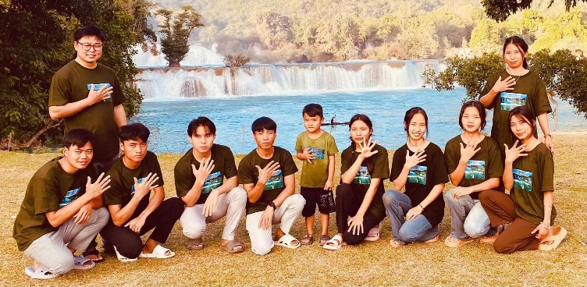

1. 一名來自緬甸的大學生分享她的見證。她是中國人，在緬甸長大。她曾經對上帝有很多的疑問。透過國際學生團契(ISF)，了解到耶穌是唯一的真神，接受了基督。儘管她的媽媽不希望她成為基督徒，但上帝還是給了她力量堅持她的信仰。

# **代禱**

# 「傳仁」2025年事工

# a) 暑期短宣的安排

# 老撾8/15-26 (舉辦漢語營及英語營)

# 印尼8/27-9/15 (個人佈道、兒童工作)

b) 本地緬甸人歸主事工：

* 因緬甸戰爭，許多緬甸學生持臨時學生簽證來美讀書。隨著川普總統再次就任

美國總統，學生心中有一种说不出来的不平安── 新的移民政策是否會讓他們的臨時簽證受到影響？請在禱告中記念他們。

# 繼續為本地緬甸人歸主事工禱告，求神興起更多教會和弟兄姊妹參入，也帶領

# 「傳仁」與其它宣教機構的合作，把福音傳給每一個人。

# 2. 緬甸事工：請繼續為緬甸禱告，使戰爭能夠盡早平息，百姓的生活能回歸正常，福音工作能持續。

# **通**

# **2024 年的捐款收據已於一月十六日以郵寄或電郵方式發送給各捐贈者。如果您到目前仍未收到捐款收據，請電郵 serve@golovefoundation.org 或致電（650）393-4095 聯繫李蓮姊妹。**

**Be Wise**

At the beginning of 2025, I believe that many brothers and sisters have made New Year's resolutions, and I hope that your New Year's plan will include daily Bible reading and prayer, as well as seizing every opportunity to evangelize. Paul's exhortation to the church in Ephesus can serve as our best New Year's resolution: "Be careful, then, how you live—not as unwise but as wise, making the most of every opportunity, because the days are evil. Therefore do not be foolish, but understand what the Lord's will is" (Ephesians 5:15-17). In the new year, by God's grace, let us act cautiously every day, cherish our time, understand God's will for us, and strive to be faithful, good, and knowledgeable servants of God!

**THANKSGIVING**

1. 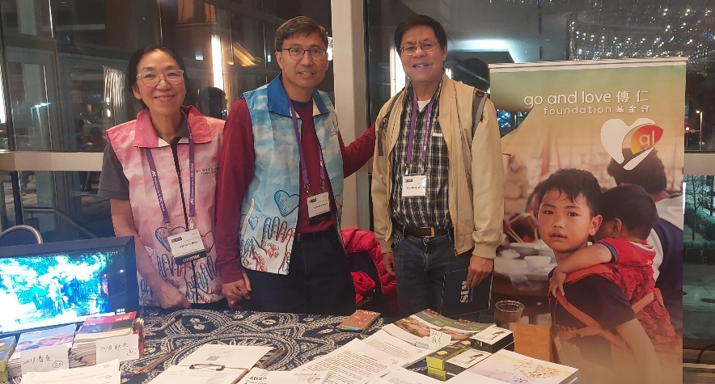At the end of last year, Brother Honwei Moy and his wife, a new co-worker, went to

the East Coast to attend a Chinese Mission Conference sponsored by Ambassador for Christ. During the meeting, many brothers and sisters who were interested in the ministry stopped by the booth to learn more about the ministry of the Go and Love Foundation, and some expressed interest in participating in this year's short-term mission trips.

1. "*For the gospel is the power of God for salvation to everyone who believes*." Many

young people who are addicted to drugs have come to the New Life Drug Rehabilitation Center in northern Myanmar to break free from their addiction and become new creations through Bible reading and prayer. Volunteers from the Go and Love Foundation participate in Bible teachings every other week. We thank God for the 10 brothers who are receiving theological training.

1. 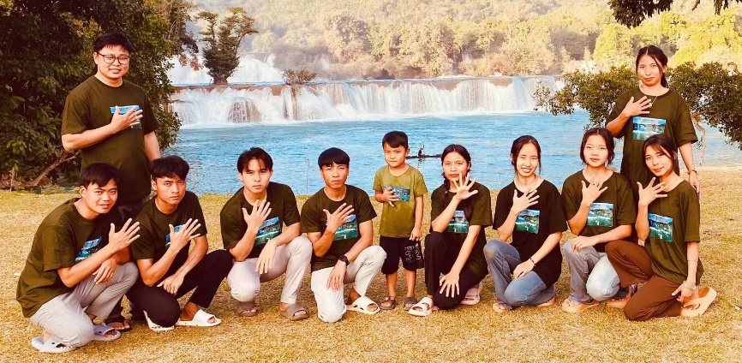The first group of children who entered the "Home of Hope" in Namsalup,

Myanmar, could not read a single Chinese word seven years ago. Today, they can write, speak, and have learned many life principles from the Bible. We thank God that these children are growing up in an environment filled with the Lord's love.

1. A Burmese student shared her testimony. She is Chinese grew up in Myanmar and

once had many questions about God. Through the International Student Fellowship, she learned that Jesus is the only true God, and accepted Christ. Even though her mother did not want her to become a Christian, God gave her the strength to stand up for her faith..

**PRAYER REQUESTS**

1. **The GOAL Ministry**

a) Arrangements for summer short-term mission trips:

* + Laos 8/15-26 (Chinese Camp & English Camp)
  + Indonesia 8/27-9/15 (Personal Evangelism, Children's Work)

b) **Local Burmese Conversion Ministry**: Due to the Myanmar War, many Burmese students have come to the United States on temporary student visas. With President Trump re-inaugurated as President of the United States, there is vocal uneasiness in the minds of students—will the new immigration policy affect their temporary visas? Please remember them in prayer.

c) Continue to pray for the conversion of local Burmese people. Ask God to raise more churches and brothers and sisters to participate, and to guide the cooperation between the Go and Love Foundation and other mission agencies to spread the gospel to everyone.

1. **Myanmar Ministries**: Please continue to pray for Myanmar, that the war may end

soon, people’s lives can return to normal, and gospel work may continue.

**Announcement**

The donation receipts for 2024 were sent to all donors via mail or email on January 16. If you have not yet received your donation receipt, please contact Sister Lian by emailing serve@golovefoundation.org or calling (650)-393-4095.