信心的培養

面對當今世界的各種挑戰，基督徒每天都需要學習對神有堅固的信心。這樣的信心是我們過得勝生活的基礎，是我們靈命成長的關鍵。那麼，如何能培養出這樣的信心呢？使徒彼得在彼得後書1:5b-8節中給了我們非常好的教導： 「有了信心，又要加上德行；有了德行，又要加上知識； 有了知識，又要加上節制；有了節制，又要加上忍耐；有了忍耐，又要加上虔誠； 有了敬虔，又要加上愛弟兄的心；有了愛弟兄的心，又要加上愛眾人的心 ，你們若充充足足地有這幾樣，就必使你們在認識我們的主耶穌基督上，不至於閒懶不結果子了。」這些層級是相互依賴、持續增長的，若能在生活中一一實踐，就能培養出堅定的信心，並結出仁愛的果實。這樣的信心不僅對個人靈命有益，也能影響周邊的人。

# 感恩

# 周會長已於9月16日結束為期近兩個月亞洲宣教之旅，平安回到灣區。感謝神使用周會長在中國不同地方鼓勵並堅固信徒、探訪助學金受惠者及他們的家庭，並與當地省教育廳聯繫有關「特殊兒童教育」項目。此外，她还在亞洲某國家進行為期三天的新工場的探討，并與當地宣教士及牧師有很好的交流。因當地英文及中文老師的需求量大，「傳仁」正尋求開展網上英文教學的可能性。在為期三周的印尼訪宣中，「傳仁」與GLOBE-S-Mission 配搭，分別在山口洋(Singkawang）、坤甸（Pontianak）和巴厘島（Bali）藉著義診、家訪、接觸幼兒園、中小學生、探訪養老院等方式與當地教會配搭，從而有機會接觸當地的穆斯林，與他們分享佈道信息。感謝神！許多成年人及學生歸信主耶穌。在印尼這個信奉回教的國家，神賜予周會長智慧和膽量，把握時機，透過翻譯與前來接受義診的回教徒一對一的分享福音信息，並帶領他們作決志禱告。主的名大大被高舉。

# 

# 

# 為南楂拉「希望之家孤兒院」感恩，雖然他們仍處在砲火的威脅下，曹院長依然每天

# 帶領同工和孩子們一同用詩歌讚美神，學習神的話語，一起仰望神的保守及供應。戰亂中，他們不忘「讓愛飛揚」，曹院長帶領幾位孩子去山區，探望難民村的家庭，並送去生活物資給他們。為曹傳道及同工們所付出的愛心向神獻上感恩。

# 

# 

# 緬甸「新生之家福音戒毒所」戰火下從臘戍遷移至東枝避難，現又遷回臘戍，蒙 神眷

# 顧保守，大人，小孩無人傷亡，經歷神所賜出人意外的平安！戰火下顛沛流離，他們仍能持守每天的敬拜，及學習神話語的機會，為他們感恩。

# 

# 代求

# 緬甸南楂拉「希望之家孤兒院」的孩子中，恩學、恩嬌、恩琴，恩善的父母均已去世。9月23日，他們在世上僅有的親人：奶奶、舅媽、表弟全都被炸死。他們死去的舅媽還留下幾個孩子，也將被接到「希望之家」。請為這些在苦難中的孩子禱告，也為曹傳道禱告。

# 2024年「傳仁」國際董事會將在十一月二日召開，周會長正在準備10月2日要寄出的事工報告及2025年事工拓展計劃，請記念。也請記念周會長的身體，求主賜恩典與力量。

The Cultivation of Faith

Confronted with today’s multiple challenges, Christians must learn to have solid faith

in God daily. This kind of faith is the foundation of a victorious life and the key to our

spiritual growth. How, then, can we cultivate this kind of faith? Apostle Peter provides

us with an excellent lesson in 2 Peter 1:5 - 8: “. make every effort to add to your faith

goodness; and to goodness, knowledge; and to knowledge, , self-control; and to

self-control, perseverance; and to perseverance, godliness; and to godliness, mutual

affection, love. If you possess these qualities in increasing measure, they will keep

you from being ineffective and unproductive in your knowledge of our Lord Jesus

Christ.”These levels are mutually reliant and continually grow; if we can practice each

one in our lives, we can then cultivate unwavering faith and produce the fruit of

benevolence. This kind of faith benefits one’s spiritual life and affects those

around one.

THANKSGIVING

1. On September 16, President Chou concluded her nearly two-month-long evangelical mission trip to Asia and safely returned to the Bay Area. Thank God for using President Chou to encourage and strengthen Christians in various places in China, visiting the recipients of scholarships and their families, as well as contacting the education department of the province about the “Special Education” project. Additionally, she conducted a three-day exploration of new fields in one of the countries in Asia and had a very good exchange with local missionaries and pastors. Because the country has a tremendous need for teachers of English and teachers of Chinese, the GOAL is examining the possibility of teaching English online.

During her three-week visit in Indonesia, GOAL, in collaboration with Globe-S-Mission and local churches in Singkawang, Pontianak, and Bali, conducted free medical clinics; visited families; met with kindergarten, elementary, and middle-school students; and visited retirement communities. Through these activities, President Chou had the opportunity to come in contact with Muslims and shared the gospel with them.

Thanks be to God! Many adults and students accepted Jesus Christ as their savior. In Indonesia, a Muslim country, God gave President Chou the wisdom and courage to seize the opportunity to preach the gospel, one on one, through a translator, to those Muslims who came to the free medical clinic. President Chou led them to their resolution prayer. The Lord’s name was thus raised high above all else.

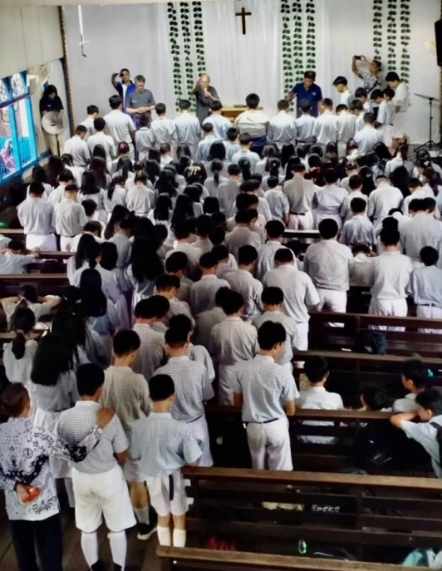

2. We offer thanks for the Home of Hope Orphanage at Namsalup. Even though they are

still under the threat of warfare, every day Pastor Cao is still leading the children and

co-workers in praising God through singing hymns, studying God’s words, and looking up for God’s protection and provision. During the war, they do not forget to let love fly. Pastor Cao, along with several children, went to mountainous areas to visit the families of refugees and provided them with daily necessities. Let us offer our gratitude to God for the benevolence of Pastor Cao and his co-workers.

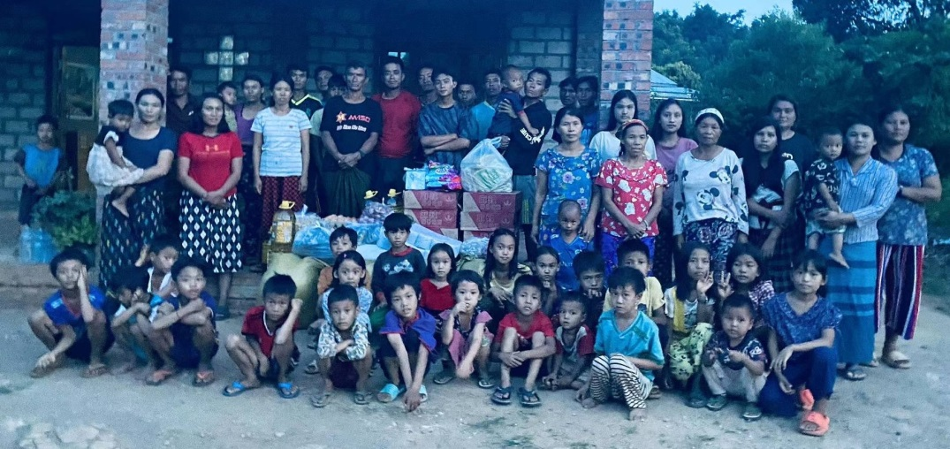

3. The New Life Drug Rehab Center, which moved from Lashio to Dongzi during the war, has now moved back to Lashio. God’s love protected the adults and the children and provided them with unexpected peace. Despite the hardships they suffered in the war,

they can still keep up with their daily prayers and the opportunity to study God’s words. Let us offer our gratitude on their behalf.

PRAYER REQUESTS

1. Among the Children of the Home of Hope Orphanage, Enshue, Enjiao, Enqing, and Enshan lost their parents, and on September 23, their only surviving relatives (grandmother, aunt, and cousins) all died during the bombing. Their aunt’s surviving children have been taken to the Hope of Home Orphanage. Please pray for these suffering children and Pastor Cao.

2. GOAL’s International Board of Directors will meet on November 2. Please keep in your prayers President Chou’s 2024 Ministry Report and Ministry Development Plan for 2025. Please also pray for President Chou’s health, asking God to give her blessings and strength.