「我的心哪，你要稱頌耶和華！」

又到了感恩的季節，希望我們大家不是只有在這個時候才記得數算神的恩典，而是像保羅教導的一樣「要常常喜樂， 不住的禱告，凡事謝恩」（帖前5:16～18a），不僅「因為這是神在基督耶穌裡向你們所定的旨意。」（帖前5：18b」，更是因為耶和華我們的神的豐富的恩典， 詩人大衛在詩篇103:3列舉幾個原因：「他赦免你的一切罪孽，醫治你的一切疾病。他救贖你的命脫離死亡，以仁愛和慈悲為你的冠冕。他用美物使你所願的得以知足，以致你如鷹返老還童。」，因此我們要事事感恩，時時感恩！

感恩
- 感恩神，「傳仁」2024年度的國際董事會於11月2日在加州順利召開，會上回顧過去一年神的帶領和恩典, 並討論了2025年事工的展望及擴展。願神的心意得到滿足！
- 我們感謝上帝為我們預備了一位全職同工負責事工推廣，並許多位義工，在財務管理、傳媒、編輯、翻譯和校對等方面為我們提供了寶貴的支持，幫助我們加強內部基礎，穩固根基。當機構在神的引領下擴展時，建立堅實的組織結構和有力的支持體系，是支撐事工健康發展的關鍵。

代禱

「傳仁」事工

1) 求神鞏固加強「傳仁」現有的事工，並引領開拓老挝及印尼兩個新的工場。求神賜力量與智慧。

2) 繼續為本地緬甸人歸主事工禱告。感謝神，「傳仁」有機會與「國際學生團契」配搭。接觸來到灣區讀書的緬甸學生。盼望藉着同工們的關懷與服侍，他們能感受到從基督來的愛，並願意歸榮耀給我們在天上的父。

緬甸事工

1) 緬北新生之家福音戒毒所

a) 臘戍戒毒中心：有二十九位戒毒的弟兄及二十位同工和他們的家屬已遷至東枝避難，有六位弟兄仍在臘戍留守，求主記念他們。

b) 東枝戒毒中心：有四十九位由臘戍逃到東枝避難的戒毒弟兄、同工和他們的家屬，另外還有五十多位難民。求神使這他們每一天透過靈修分享，能夠更認識神。

c) 勐速戒毒中心：請為他們日常所需（糧食、菜蔬、燃油的供给）禱告，也為他們

屬靈生命的成長禱告。

2) 最近緬軍用戰鬥機轟炸貴概，「貴概聖光學校」及貴概華人浸信會禮拜堂的建築物

部份被炸損毀嚴重。目前還不曉得傷亡情況，請求神眷顧老師，學生及家人們的安全。

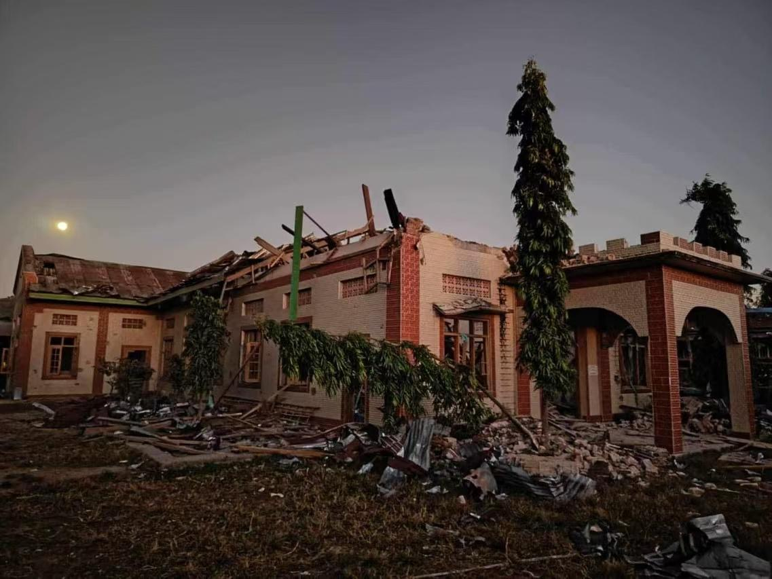

3) 一個八年前母親因車禍死亡，父親染上毒癮已不之去向，一直由爺爺奶奶撫養的10歲孤兒恩绍，因爺爺奶奶身體欠佳，不能繼續撫養，現送至「希望之家」。求神憐憫醫治恩绍幼小心靈所受的創傷，盼望他在「希望之家」能找到從神來的希望及愛。

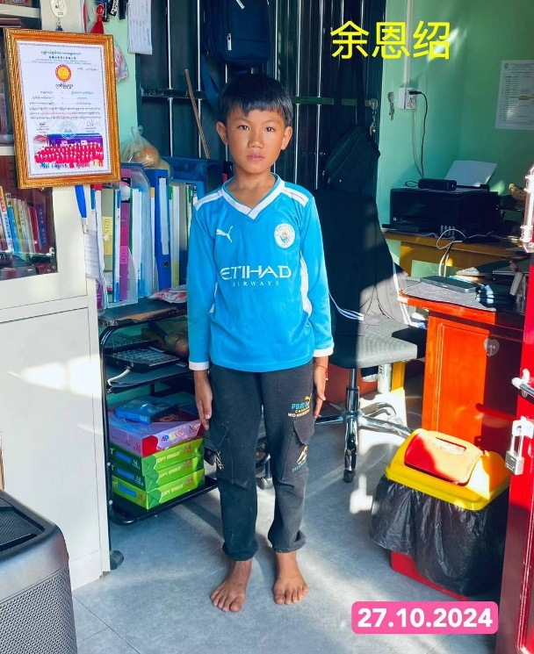

"Bless the Lord, my soul."

It is once again the season of Thanksgiving! I hope we all remember to count God's grace not just during this season but at all times, as Paul teaches us in 1 Thessalonians 5:16-18a, "Rejoice always; pray continually; give thanks in all circumstances.”In addition, we are thankful not only because "this is God's will in Christ Jesus," as Paul says in 1 Thessalonians 5:18b, but because it is the abundant Grace of the Lord our God.

The psalmist David provides several reasons for gratitude in Psalm 103:3, "He forgives all your sins and heals all your diseases." He redeems your life from death and crowns you with love and mercy. He has fulfilled your desires with good things, so that you may be rejuvenated like an eagle." Therefore, let us be thankful for everything, and be thankful all the time!

THANKSGIVING

On November 2, the 2024 International Board of

Directors were successfully held in California. We reviewed God's leading and His Grace over the past year and discussed the outlook and expansion of the ministry in 2025. May God's heart be satisfied!

We are grateful to God for providing us with a full-time staff

member to be responsible for the mobilization of the ministry and many volunteers who have provided us with invaluable support in the areas of financial management, media, editing, translation, and proofreading, helping us to strengthen our internal foundation and solid our foundation. As an organization expands under God's guidance, building a solid organizational structure and a strong support system is key to supporting the healthy development of the ministry.

PRAYER

1. The GOAL Ministry

1) Pray that God will strengthen the existing ministry of the GOAL and lead the development of two new mission fields in Laos and Indonesia. Pray for strength and wisdom.

2) Continue to pray for the conversion of the local Burmese people. Thank God that the GOAL can partner with the International Students Fellowship. Reach out to Burmese students studying in the Bay Area. I hope that through the care and service of the co-workers, they will feel the love of Christ and be willing to glorify our Father in heaven.

2. Myanmar Ministry

1) New Life Drug Rehabilitation Center

a) Lashio Drug Rehabilitation Center: Twenty-nine brothers and 20 co-workers and their families have been relocated to Taunggyi for refuge, and six brothers are still staying in Lashio.

b) Taunggyi Drug Rehabilitation Center: There are 49 drug addiction rehabilitation brothers, co-workers, and their families who have fled from Lashio to Taunggyi for refuge, as well as more than 50 refugees. Pray that they will be able to know God better through spiritual sharing every day.

c) Mengsu Drug Rehabilitation Center: Please pray for their daily needs (food, vegetables, fuel) and their spiritual growth.

2) Recently, the Burmese military bombed the "Kutkai Holy Light School" and the Kutkai Chinese Baptist Church. Some of the buildings were badly damaged by the bombing. We are not yet aware of the casualties, and we ask God to take care of the safety of teachers, students, and families.

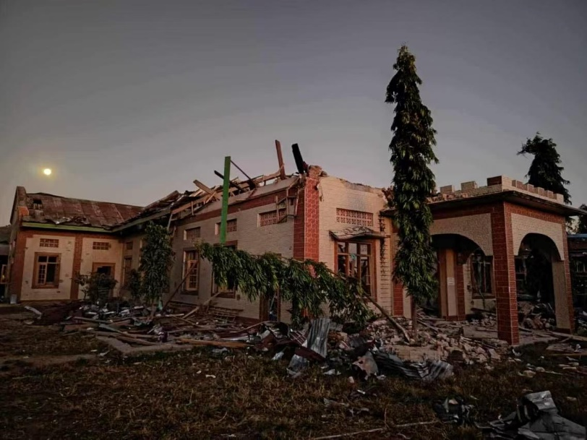

3) Enshao is a 10-year-old orphan whose mother died in a car accident eight years ago. His father was addicted to drugs and left home without knowing where to go, leaving his grandparents to raise him. Enshao has been sent to the “Home of Hope” as his grandparents are unable to continue to raise him because of their physical weakness. Pray that God will have mercy and heal the hurts of Enshao's young heart and that he will find hope and the Love of God in the "Home of Hope".

