# 佳美的腳蹤

根據2024年的一個統計，世界上有81億人口，至少有34億人沒有聽過福音。為了這些失喪的靈魂，有多少響應神呼召的弟兄姊妹把他們自己全然獻上，在各個福音工場不辭辛勞分享福音。他們有這樣的心志和使命感，是因為他們對神有堅定的信心，並享受與神同工的喜樂，正如先知以賽亞說的「傳福音報喜信的人，他們的腳踪何等佳美！」（賽52:7）。求神的靈感動更多的弟兄姊妹成為「傳福音報喜信」的使者，願他們懷着搶救靈魂的迫切感，將耶穌的愛和救恩傳遞給每一位未曾聽到福音的人，在神的眼中他們的腳踪何其佳美！

## 感恩

1. 主耶穌說，「你們來看！(約1:39) 這一次，當「傳仁」的董事和同工願意離開他們熟悉的環境，去到主要他們去的地方，他們看到在福音難被接受的地方，仍有許多主的僕人和使女，他們順服主，活出基督的生命；他們也看到，當有人願意去到水深之處撒網的時候， 大批的魚就被撈上來，榮耀歸主名！

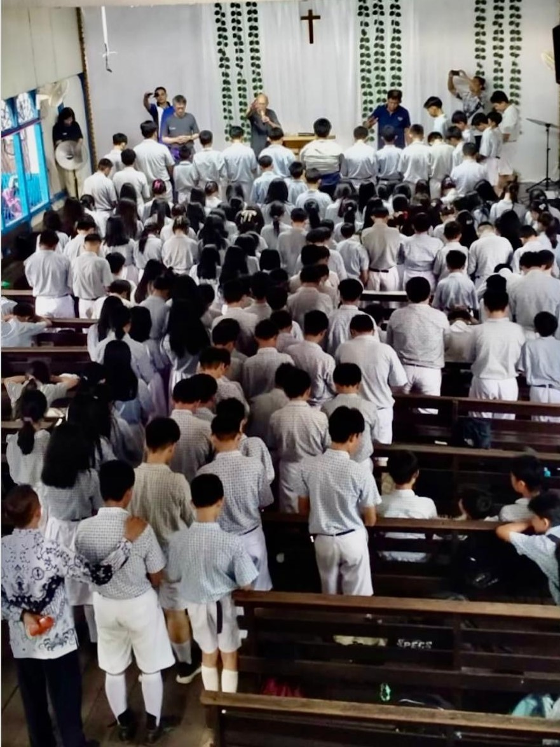

1. 一位服事痲瘋康復者多年的弟兄，過去在康復者中間僅限給屬靈方面的供應，也帶領了多人歸信基督。最近，他靠主突破了自己的心理障礙，親自動手護理康復者的患處，且看到患者的傷口癒合，從而大得鼓勵。

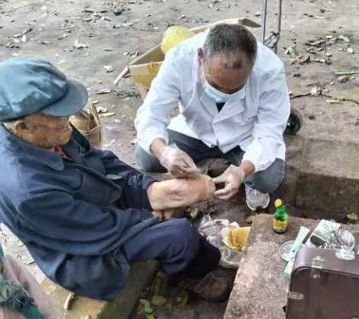

1. 為「傳仁」許多義工感恩，無論是財務協助、校對、翻譯、網課、傳媒…等等，都成為我們的助力。

## 代禱

1. 「傳仁」事工
   1. 「傳仁」將於11月2日召開國際董事會。會議將討論2025年事工的拓展，極需要聖靈的引導，請在禱告中記念。
   2. 為本地緬甸人歸主事工禱告，求神興起更多教會和弟兄姊妹參入，也帶領「傳仁」與其它宣教機構的合作，把福音傳給每一個人。
2. 緬甸事工：
   1. 自去年10月27日緬甸內戰開始，直到今天我們都無法聯繫位於貴概的两所基督教中學，「貴概聖光學校」及「得恩中學」，請切切記念老師和學生及家人們的安全。
   2. 緬北新生之家三個戒毒中心雖然戰火未平熄，但每隔一週週二晚上(緬甸周三早上)

的網絡聖經課程仍能持續。求神保守學員們的學習及安危。

* 1. 緬北南楂拉「希望之家孤兒院」的曹國能院長，10月初送了8位孩童去位於掸邦當陽縣讀高中。「傳仁」會長透過網絡給予孩子們勸勉，鼓勵他們努力讀書，並要學習敬畏神。求神眷顧保守這些孩子在外地讀書時仍能保持自律的生活。



Beautiful Footsteps

According to 2024 statistics, there are 81 hundred million people worldwide. Among them, 34 hundred million have not heard the gospel. In the interest of these lost souls and responding to God’s call, many brothers and sisters have dedicated themselves completely and tirelessly to spreading the gospel. They are dedicated and duty-bound because they firmly believe in God and enjoy working with it. Just as Prophet Isaiah said, “How beautiful…are the feet of those who bring good news….”(Isaiah 52:7). We pray that God’s inspiration will move even more brothers and sisters to become envoys who “spread the gospel and bring good news.” We hope they will be filled with the urgency of saving souls to spread Jesus Christ’s love to every person who has never heard the gospel. How beautiful their feet will be.

THANKSGIVING

1. The Lord Jesus said, “ Come, and you will see.” (John:1:39) This time, when GOAL’s board of directors and coworkers willingly left their familiar environment and went to where the Lord wanted them to go, they witnessed that, in places where it is very difficult to spread the gospel, many of God’s servants and ambassadors obeyed the Lord and have lived out the lives of Christians. The board of directors and coworkers also witnessed that, when people are willing to throw the fishing net in the deep part of the water, they will be able to bring up an abundant number of fish to glorify the Lord’s name!

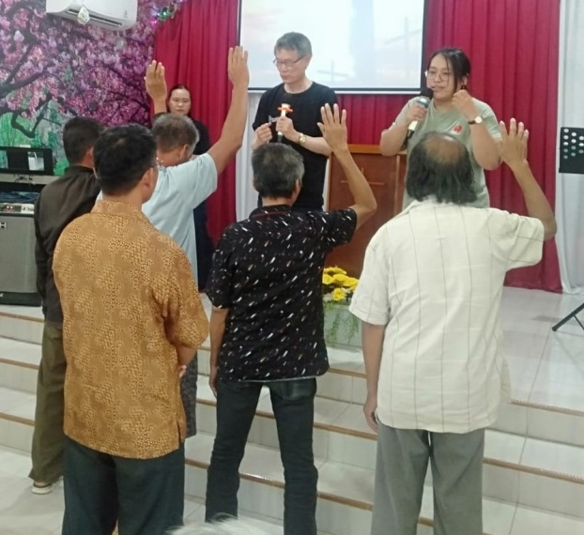

1. A brother who served rehabilitated lepers for many years and used to supply only spiritual provisions has also led quite a few rehabilitated lepers to embrace Christ. Recently, by relying on God, he has overcome his mental blocks and received great encouragement when he treated the lepers’ affected areas and witnessed their healing.

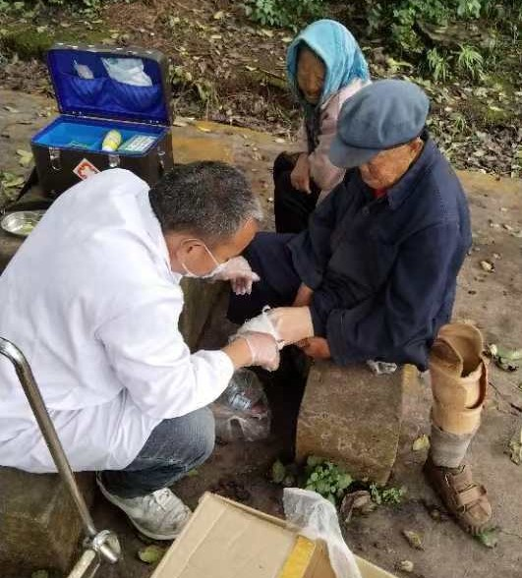

1. We thank God for many of our volunteers. They are all our helping hands, whether in bookkeeping, editing, translating, virtual teaching, media advertising, etc.

PRAYERS

1. The Ministry of the GOAL

a. GOAL’s board of directors’ meeting will be held on November 2nd The meeting will discuss the expansion of the ministry in 2025, and the guidance of the Holy Spirit is greatly needed.

b. Pray for the local Burmese conversion ministry; ask God to raise more churches and brothers and sisters to participate, as well as lead GOAL to cooperate with other missionary agencies to spread the gospel to everyone.

2. The Myanmar Ministry

1. From the beginning of Myanmar’s civil war on October 27 last year to this day, we have not been able to get in touch with the two Christian middle schools in Kutkai: The Kutkai Holy Light School and The Grace Private School. Please remember the teachers, students, and their families.
2. Although the civil war has not ended in Northern Myanmar, where the three New Life Drug Rehab centers are situated, the virtual Bible class is still held on Tuesday evenings every other week (Wednesday morning in Myanmar).
3. Principal Cao of the Home of Hope Orphanage in Namsalup in Northern Myanmar took 8 children to Tangyan, Shan State, Myanmar to attend high school. Through the Internet, President Chou encouraged them to study hard and to learn to revere God. Pray that God will look after these children to make sure that they will discipline themselves while studying away from their hometown.

