公義慈愛的神

最近在巴黎舉辦的奧運會上出現了各種各樣不堪入目的亂象。這種現象的本質并沒有什麼新鮮，因為「已有的事，後必再有；已行的事，後必再行。日光之下，並無新事」（傳1:9）但我们的神是公義的神，也是慈愛的神，因為「公義和公平是你寶座的根基，慈愛信實行在你前面」（詩89:14）。 基督徒應該清醒地意識到主耶穌基督再來的日子近了。在這末世的時代，我們要警醒，「要靠著主，倚賴祂的大能大力，作剛強的人。要穿戴神所賜的全副軍裝，就能抵擋魔鬼的詭計」 (弗6:10a-11)。我們要把自己當作活祭獻給神，讓福音傳遍到世界的每個角落。

# **感恩**

# 1. 為「傳仁」在緬甸的合作夥伴們感恩。其中，位於南楂拉的「希望之家孤兒院」正處在砲火的威脅下。孤兒院的曹院長/傳道除了照顧51位院童的生活，还要接待超過100位難民；此外，「新生之家福音戒毒所」因躲避砲彈的襲擊，已從臘戍搬遷至東枝較安全的地方。在危難中，戒毒所的楊牧師和同工仍伸出援手幫助100多位的難民，彰顯神的愛。為曹傳道、楊牧師及同工們所付出的愛心向神獻上感恩。

# 

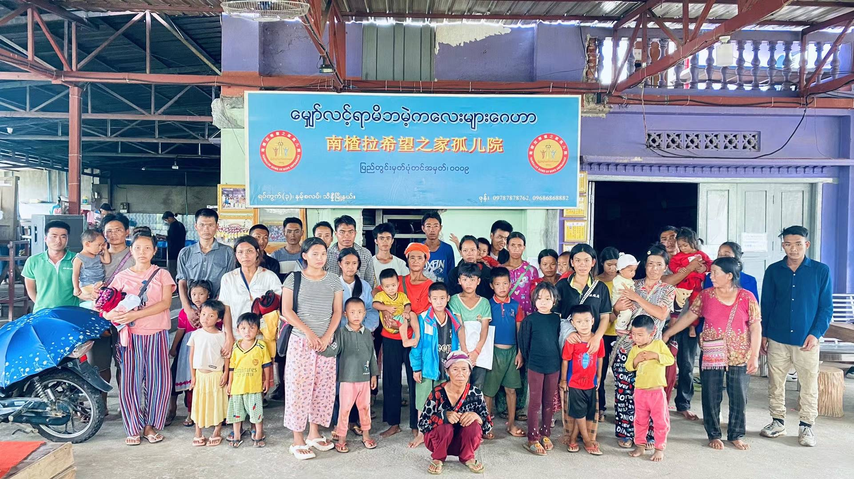

# 2. 感謝神，過去一個月使用周會長，在中國各地鼓勵並堅固信徒、探訪助學金的受惠者及他們的家庭，並與官方聯繫有關「特殊兒童教育」項目。

# 

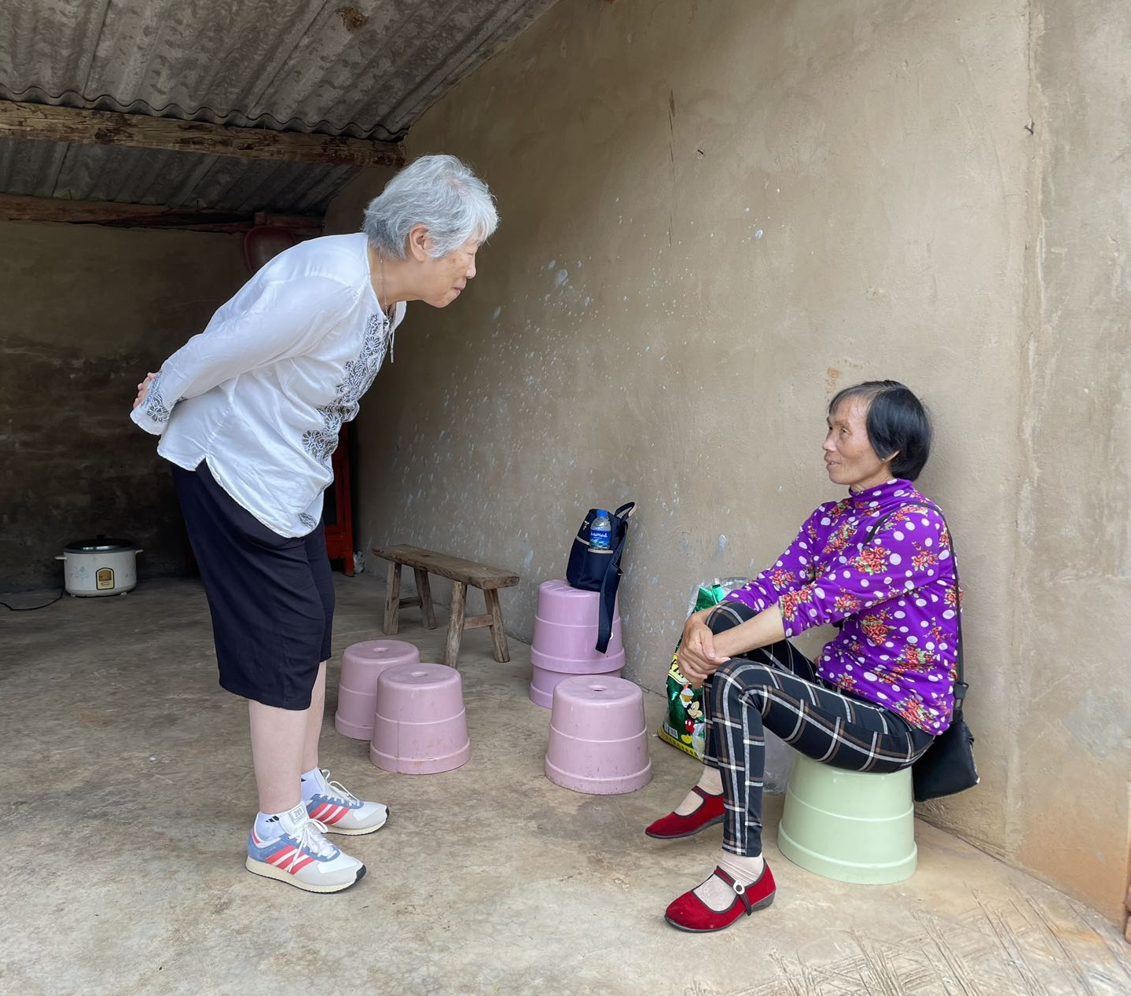

# **代禱**

# **1. 「傳仁」事工**

# a. 周會長正在中國探訪，随后將去東南亞兩個國家。因天氣炎熱，加上舟車勞頓，抵抗力降低，周會長在中國感染新冠。因前面東南亞的行程也很重要，關乎「傳仁」的未來。求神保守帶領周會長，並看顧她的身體。

# b. 為「傳仁」在中國將與當地民辦教育配合的「特殊兒童教育」事工禱告，懇求聖靈帶領，讓更多患自閉症、腦癱、眼瞎、耳聾的兒童能得到適當的關顧及學習的機會。

# c. 為進一步開展本地跨文化福音事工禱告，求神興起更多教會和弟兄姊妹參入，也帶領「傳仁」與其它宣教機構的有機地合作，把福音傳給每一個人。

# **2. 緬甸事工：**

# 請繼續為緬甸的政治動盪禱告。因戰爭造成的物質缺乏，物價上漲，民不聊生。求神憐憫這地及這地上的百姓，但願他們能從救主耶穌基督找到真正的平安。

1. 因緬甸內戰蔓延，大家都趕著從臘戍逃離到東枝，請大家迫切為他們的安危禱告！

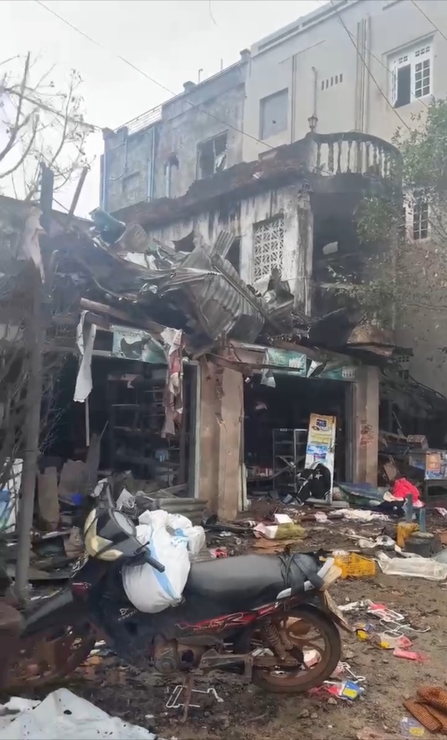

1. 東枝新生之家現有弟兄同工及其他避難人員超過100人，也求神施恩賜福保守！

d . 求神堅立緬甸各地的同工，在極其艱難的環境中，加添他們身心靈的力量去牧養群羊，並眷顧因戰爭導致家破人亡, 流離失所的百姓。

The Just and Loving God

A lot of weird events happened at the Olympics in Paris recently.  These events were, in essence, not new, for “What has been will be again; what has been done, will be done again; there is nothing new under the sun.”(Ecclesiastes 1:9) But our god is righteous and kind, for “Righteousness and justice are the foundation of your throne; love and faithfulness go before you.”(Psalms 89:14) Christians should be very much aware that the Second Coming is near.  At these end-of-an-era times, we should be alert, “...be strong in the Lord and in his mighty power.  Put on the full armor of God, so that you can take your stand against the devil's schemes.**”**(Ephesians 6: 10a-11). We have to become living offerings to the Lord and spread the gospel to every corner of the world.

Thanksgiving

1. We thank the Lord for the co-workers in Myanmar.  Among them, the Home of Hope Orphanage in Namsalup is in the midst of warfare.  Aside from taking care of the lives of 51 resident-orphans, Minister Cao has to accept more than 100 refugees.  Additionally, the New Life Drug Rehabilitation Center has moved from Lashio to a safe location in Taunggyi.  In these dangerous times, Pastor Yang and his coworkers have helped more than 100 refugees, manifesting God’s love. We thank God for the love manifested by Minister Cao and Pastor Yang, as well as their coworkers.

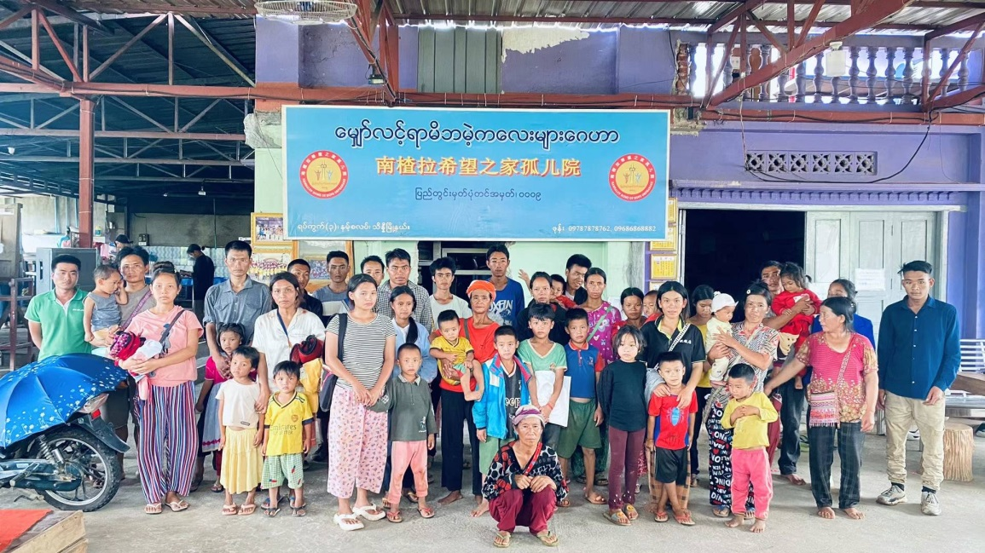

# Thanks to God that during the past month, President Chou encouraged and strengthened the disciples at various places in China.  She visited the recipients of financial aid and their families.  And she also contacted the government regarding the Special Children’s Education initiative.

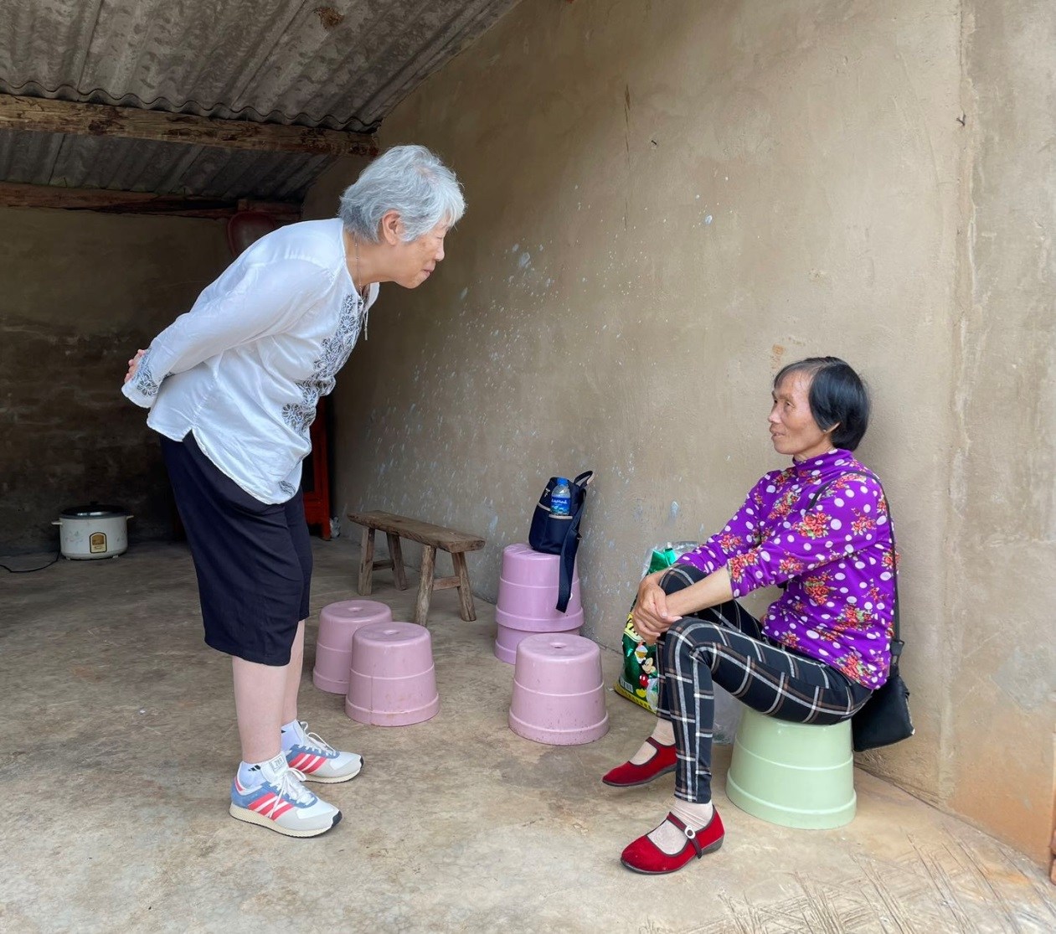

Prayers

1. The Ministry of GOAL:
2. President Chou is visiting China.  Later, she will visit two Southeast Asian countries.  The extreme heat, along with fatigue incurred during her travels lowered her immunity and caused her to contract Covid in China.  Because her visit to the two countries in Southest Asia are very important to the future of GOAL, we ask God to lead and protect President Chou, as well as take care of her physical well-being.
3. Pray for GOAL’s upcoming project of cooperating with the local government’s “Special Children's Education.”  Pray that the Holy Spirit will lead the project so that more children who are afflicted by autism, cerebral palsy, blindness, and deafness will receive proper care and learning opportunities.
4. Pray for the cross-cultural mission; pray that more churches and brothers and sisters in Christ will participate and lead GOAL to cooperate with other evangelical churches so as to spread the gospel to everyone.

# Myanmar Ministries:

1. Please continue to pray for Myanmar’s political unrest.  The war caused a scarcity of goods and price increase, creating an extreme hardship for the people.  Pray that God will have pity for the people in Myanmar.
2. The spreading of Myanmar’s civil war made a lot of people escape from Lashio to Taunggyi.  Please earnestly pray for their safety.



1. There are more than 100 brothers, co-workers, and refugees in Taunggyi New Life Drug Rehabilitation Center.  Please pray for God’s blessings and protection for them.
2. Please pray that God will strengthen our co-workers at various places in Myanmar, increase their spiritual strength to care for their sheep, and protect the homeless people who have lost their families in the war.