唯獨全心信靠
主耶穌再來的日子近了，但世界上還有許多人未聽聞福音，向這些未得之民傳福音充滿了各樣的未知和挑戰。先知以賽亞提醒我们：「你們當倚靠耶和華直到永遠，因為耶和華是永久的磐石。」（賽26章4節）我們只要全心倚賴神，尤其在前景不明和困頓的時候，確信祂是我們隨時的幫助，就會毫無畏懼地傳揚耶穌基督的救恩。

感恩

1. 感謝神的帶領，傳仁基金會（傳仁）的部份事工在受到戰難和政治因素的影響下，神讓我們看到本地跨文化事工的契機，並帶領我們與當地緬甸教會及其它機構、教會配搭，一起作成神託付我們的工作。願一切榮耀歸給神！

2. 緬甸新生之家福音戒毒所目前有七位傳道人(臘戍三位、東枝兩位、勐速兩位)。截止今年，該福音戒毒所已派送十一位弟兄去仰光接受神學裝備。為這一項聖工感恩。許多吸毒不能自拔的年輕人，來到戒毒所，靠著禱告及福音的大能，脫離了毒品的綑綁，悔改信主，成為新造的人。其中有些更願意委身接受裝備成為全職傳道人，以幫助更多被毒品挾制的年輕人走出黑暗，進入光明。願神的榮耀在這裡大大的彰顯。

代禱

1. 「傳仁」事工

a. 求神帶領「傳仁」2024年度的各項事工，周會長將於2024年7月去中國，並在8-9月探討兩個未得之民群體，求神帶領。

b. 為進一步開展本地跨文化福音事工禱告，求神興起更多教會和弟兄姊妹參入，也帶領「傳仁」與其它宣教機構的合作，完成神所託付的大使命。

2. 緬甸事工：

a) 為緬甸的和平禱告，尤其是最近緬北局勢再度緊張，多處交通路段被挖斷，導致車輛無法通行。民盟軍隨時準備開戰，求神保守同工和孩子們的平安。求神藉此能讓更多人信靠耶穌基督，得享真正的平安。

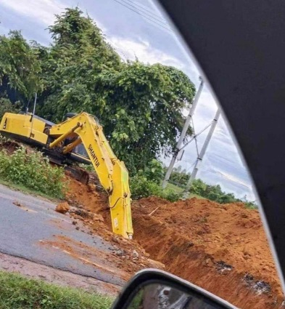

b) 求神大大堅立各地的同工，讓他們無論在順境或逆境中都能仰望神，持守所信的道，靠主恩典同心合一地去完成神所託付的使命。

c) 正在擴建的南楂拉希望之家學生宿舍樓，盼望8月能順利完工，請代禱，求神帶領。

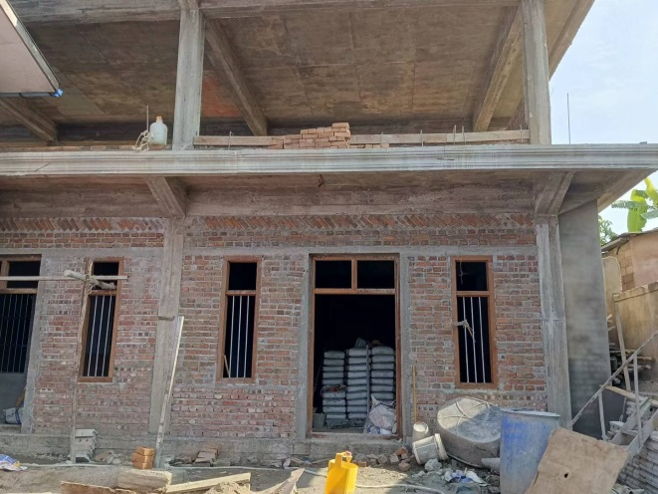

Trust with All Your Heart

The day of Jesus' return is near, but there are still many people in the world who have

not heard the gospel, and preaching the gospel to these unreached people is full of

all kinds of unknowns and challenges. The prophet Isaiah reminds us: "Trust in the Lord forever, for the Lord Himself is the Rock eternal." (Isaiah 26:4) When we trust God with all our hearts, especially in times of uncertainty and hardship, and are confident that He is our ever-present help, we will be able to proclaim the salvation of Jesus Christ without fear.

THANKSGIVING

Thanks to God's guidance, although some of the ministries of the Go and Love

Foundation (GOAL) have been affected by war and political factors, God has allowed us to see the opportunity of cross-cultural ministry in the local area, and led us to partner with the local Burmese church as well as other organizations and churches to do the work entrusted to us by God. May all glory be to God!

The New Life Drug Rehabilitation Centre currently has seven ministers (three in

Lashio, two in Taunggyi, and two in Mong Su). As of this year, the Drug Rehabilitation Center has sent 11 brothers to Yangon for theological training. Be thankful for this work. Many young people who are addicted to drugs and cannot extricate themselves from their addiction have come to the drug rehabilitation center, where by the power of prayer and the gospel, they are freed from the bondage of drugs, they have repented and become new creatures. Some of them are willing to commit themselves to being equipped to become full-time ministers so as to help more young people who are held hostage by drugs to walk out of the darkness and into the light. May the glory of God be greatly demonstrated here.

INTERCESSION

1. "GOAL" Ministry

a. Pray for God's guidance in the work of the Go and Love Foundation in 2024

President Chou will travel to China in July 2024 and explore two groups of unreached

people in August-September.

b. Pray for further development of local cross-cultural evangelistic work. Pray that

God will raise more churches and brothers and sisters to participate, as well as lead the

cooperation between "GOAL" and other mission organizations to fulfill the Great

Commission entrusted by God.

2. Myanmar Ministries:

a. Pray for peace in Myanmar, especially as tensions have recently returned in

northern Myanmar, where sections of roadways have been cut off and made impassable

by vehicles. The NLD forces are ready to go to war. Pray that God will protect the co-

workers and the children. Pray that God will use this opportunity to make more people

trust Jesus Christ and gain true peace.

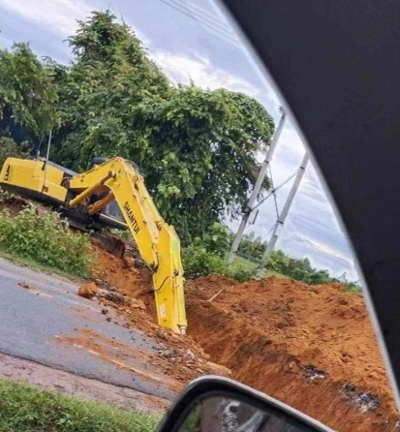

b. Pray that God will greatly strengthen our fellow workers everywhere, so that they

can look to God in good times and bad, hold fast to the word they believe, and work

together in the Lord's grace to fulfill the mission entrusted by God.

c. The student dormitory building of the Lamsalup Home of Hope is being expanded. We look forward to its successful completion in August.

