六月份感恩與代求
「使人和睦的人有福了！」
「使人和睦的人有福了！因為他們必稱為神的兒子。｣ 馬太福音 5:9

感恩
- 緬北貴概聖光學校開學以來，遠距教學經常面對斷線問題，直接影響上課進程。加上多雨的天氣也使得學生出席率降低。感謝 神，即使在諸般的困難下，老師們不洩氣，格外地顯出愛心，耐心地等候學生，並以關心的口吻虛寒問暖，激發學生學習的熱情。當老師看到學生們努力學習，在課堂上能流利順暢地用英語介紹自己時，一切的勞苦都值得了。
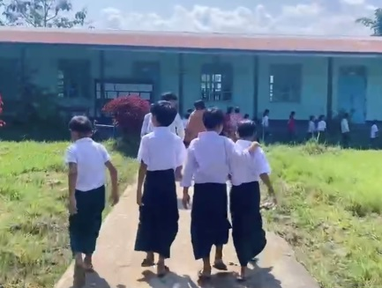
- 感謝主，在局勢動盪中依然保守「南楂拉希望之家孤兒院」的孩子們還可以繼續在這個大家庭裏學習中文、緬文。6月2日緬文學校開學了，又是新的一年新的起點！ 願孩子們都健康、平安，獲得好成績榮耀主聖名。

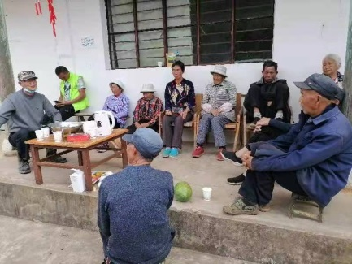
- Z傳道多年來以基督的愛關心弱勢群體。他請來志願者醫生醫治他們身體上病痛，並藉著耶穌基督的救恩，使他們的靈魂得到醫治。這些被世人遺棄的群體，主卻看他們為寶貴。正如主耶穌進聖城時，騎的是一頭不起眼的驢駒。主說，若有人問為何時，就說，「主要用他！」(參可11:1-3)。今天這些弱勢群體，其中已有弟兄被裝備出來帶查經、作話語的出口。 感謝不偏待人的 神，「福音本是 神的大能，要救一切相信的。」(羅1:16)

代求
- 「傳仁」的網頁，在內容與編排上有待更新。我們成立了網絡設計工作小組，特別感謝有義工參與這項工作。除了更新頁面設計、內容及編排，我們將會增添讀者的反饋欄。請為網頁更新禱告。

- 「傳仁」春夏季的刊物「觸動」正在校對及設計中，請記念。這一期的內容集中於「教育」方面的討論。「教育」是貧困孩子的一條出路，同時也影響著一個國家的發展。除了主題文章，本期內容還包含參與「教師培訓」三位老師的分享。

- 「緬北南楂拉希望之家孤兒院」2020年已在緬政府註冊成為一合法的單位。政變於2021年2月開始至今仍未平息。目前的軍政府要求孩子們必須去政府辦的緬文學校讀書，否則將對他們採取制裁措施；可是如果去政府學校就讀，民盟軍則認為「希望之家」是親軍政府的。於是，他們陷在兩難之間。求主特別賜曹傳道及「傳仁」同工智慧，更求 神引導當行的路。
Praise and Prayer Requests

“Blessed are the peacemakers!”

“Blessed are the peacemakers, for they will be called children of God.” Matthew 5:9

Praise:
- Ever since school started for Kutkai Holy Light Christian School in North
Myanmar, there has been continuous internet disconnection issues that directly affected the progress of distance learning. The rainy weather has compounded the problem, causing student attendance to drop further. In spite of all these difficulties, however, thank God for the teachers’ persistence, which revealed their love even more as they waited patiently for the students. Their care and concern for the students motivated the students to learn enthusiastically. When the teachers see how hard the students are trying to learn and are able to introduce themselves in fluent English during class, all the effort is worthwhile.

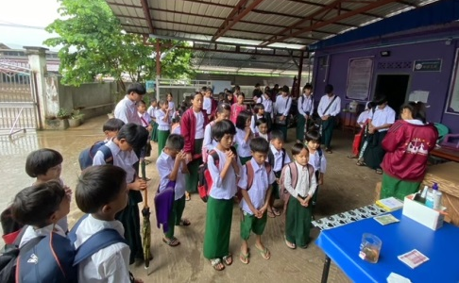
- Praise the Lord for watching over all the children in the Home of Hope in
Namsalup. Even in this unsettling time, the children can continue to learn Chinese and Burmese. Burmese school started on 6/2 which marked another new school year and a new beginning! May all the children remain healthy, safe, and capable of glorifying God’s Name by earning good grades.

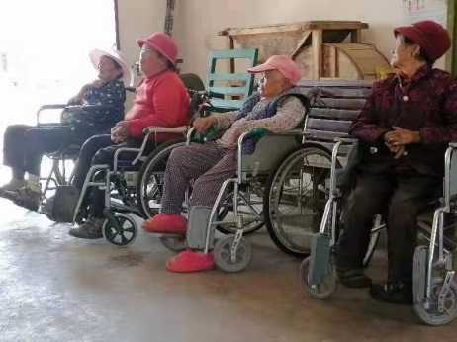
- For many years, Minister Z has been caring for the underprivileged with
Christ’s love. He brought in volunteer doctors to treat the patients’ physical ailments and meet their spiritual needs through Christ’s salvation. These people are abandoned by the world but are precious in Jesus’ eyes, reminding us of the way Jesus entered Jerusalem—He was riding an unremarkable colt. The Lord said that if anyone asked what the colt was for, say “The Lord needs it!” (see Mark 11:1-3). Today, within these underprivileged communities, there are already fellow believers who have been equipped to lead Bible Studies and proclaim the gospel. Praise God that He does not show favoritism. “… the gospel… is the power of God that brings salvation to everyone who believes…” (Romans 1:16).

Prayers:
- The Go and Love website will be updated. A website design task force
was formed. We are especially grateful to all the volunteers who are involved in this project. In addition to updating the web page design, content, and layout, we will also be adding a readers’ feedback section. Please pray for this web page update.

- Please remember the spring/summer issue of GAL newsletter Touching
Lives in your prayers as it is undergoing the proofreading and design process. The content of this issue focuses on the discussion of “education.” “Education” is a way for children to get out of poverty. It also affects the development of a country. Besides the main article in this publication, there will also be sharing from three teachers who were part of the teacher training effort.

- The Home of Hope in Namsalup was registered as a legal entity under
the Myanmar government in 2020. The coup that began in February 2021 is still ongoing. The current military government requires the children to attend government-run Burmese schools. Otherwise, sanctions will be imposed on them. On the other hand, if the children attend the government schools, the civilian allied force sees the Home of Hope as siding with the military government. Please pray that the Lord will grant special wisdom to Minister Cao and GAL staff and guide them in the way they should go as long as they are caught in this quandary.

Blessings in Christ!

With Love,
Betty Chou and the Go and Love Foundation

