一月份感恩與代求
「求我們主耶穌基督的 神，榮耀的父，將屬靈的智慧和啟示賞給你們，使你們更知道他。」以弗所書 1:17

感恩
- 2021年，對每一個人來說都是不容易的，對福音機構尤是。但我們仍然定睛在那賜永恆盼望的 神身上，經歷祂同在的恩典。過去的一年， 主給我們增添了許多位義工。他們在教導、文字翻譯及校對上給予我們很大的幫助。 事工方面，雖然有疫情，網絡教學仍能繼續。經費上的需要， 神讓我們學習，不向人開口，而是「向祂大大的張口，祂就給我們充滿。」(詩81:10) 我們收到許多無私的捐款，超過我們所求所想。這再次見證，那呼召我們的是信實的！當我們憑信心去給的時候，「罈內的麵果不減少，瓶裏的油也不缺短，正如耶和華藉以利亞所說的應許。」(王上17:16) 願一切榮耀頌讚歸給 神。

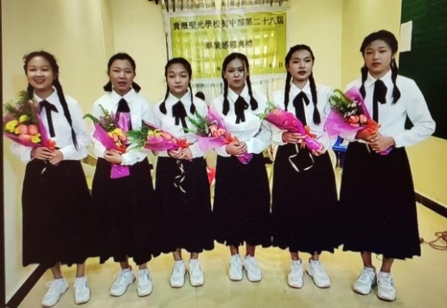
- 因疫情及貧困等諸多因素的影響，緬北貴概聖光學校初中部僅有21位通過網絡上課的學生。去年12月30日，该校舉辦第28屆初中部畢業典禮，有6位學生畢業。這些孩子原本初中畢業就要外出赚錢，但現在他們願意留下繼續讀高中。我們為此感謝 神！畢業典禮當天，「傳仁」會長以聖經以弗所書5:15-17節「你們要謹慎行事，不要像愚昧人，當像智慧人。要愛惜光陰，因為現今的世代邪惡。不要作糊塗人，要明白主的旨意如何。」勸勉同學們要「作智慧人」，因現今的世代邪惡。緬北貴概聖光學校的校長將於今年三月重啟已停了五年的高中部。為三月開始的網課已預備好的志願者老師感恩。

代求
- 今年 2月 7-28日「傳仁」已安排了志願者老師給緬北數所學校的老師提供網上師資培訓。請記念！

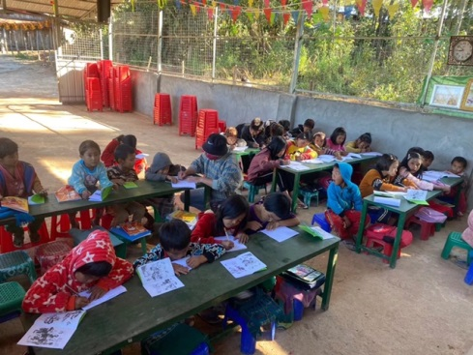
- 請記念緬北南楂拉「希望之家」在弄砍村的福音外展工作。那裏沒有學校，很多孩子失去讀書的機會。 神感動李銀富傳道願意去到沒有網絡，沒有電的弄砍村服事那裏的孩童，教導幼稚園和一年級的孩童識字福音。

- 請記念「希望之家」的孩子們。他們每天課業重，學習壓力非常大！沒有專業老師教課，老師均為軍人。

連接秋季「觸動」中文電子版:
https://golovefoundation.org/main/wp-content/uploads/2022/01/NL_Fall-2021-C-v3-1-1.pdf

Praise and Prayer Requests

“I keep asking that the God of our Lord Jesus Christ, the glorious Father, may give you the Spirit of wisdom and revelation, so that you may know him better.” Ephesians 1:17

Praise:
- The past year hasn’t been an easy one for everyone and it is even more so for Christian organizations. However, as we experience God’s grace and presence, we continue to focus on Him who is the giver of eternal hope. Last year, the Lord blessed and increased us with many volunteers. This helped us tremendously in terms of teaching, text translation, and proofreading. On the ministry side, online teaching continues despite of the pandemic. As for the need for finances, God helped us to learn not to ask people and rather “open wide your mouth and I will fill it.” (Psalm 81:10) Many selfless donations came in beyond what we prayed for and expected. Once again, this proved that the one who calls us is indeed faithful! As we learn to give by faith, “…the jar of flour was not used up and the jug of oil did not run dry, in keeping with the word of the Lord spoken by Elijah.” (1 Kings 17:16) May all the glory and praise be to God.

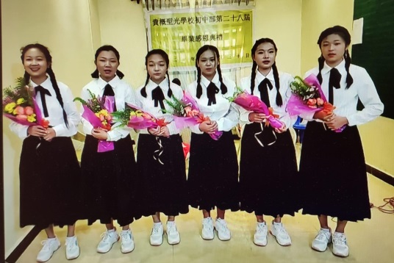
- Because of pandemic and poverty reasons, there are only 21 students left to take online classes in the junior high division at Kutkai Holy Light Christian School in North Myanmar. On 12/30, the school held its 28th Junior High Graduation Ceremony with 6 graduates. Originally, these students had to go out to earn money after they graduated from junior high. Thank God that they are now willing to stay and continue their high school education. At the graduation ceremony, Go and Love president used Ephesians 5:15-17 in the Bible “Be very careful, then, how you live—not as unwise but as wise, making the most of every opportunity, because the days are evil. Therefore, do not be foolish, but understand what the Lord’s will is.” to encourage the students to “be wise” because the present age is evil. This March, the principal of Kutkai Holy Light Christian School will restart the high school division after it has been closed for five years. We give thanks for preparing volunteer teachers for online classes in March.

Prayers:
- Go and Love has arranged a volunteer teacher to provide online teachers training for several schools in North Myanmar from 2/7-2/28. Please remember this in your prayers!

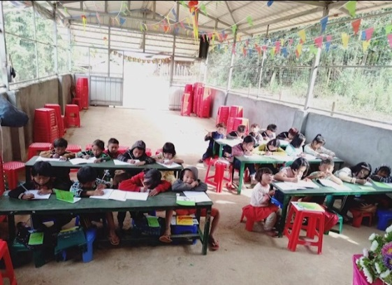
- Please remember the gospel outreach ministry in Long-Kun village by the Home of Hope in Namsalup, North Myanmar. There is no school in the area and many children loss the opportunity to study. God moved Minister Yinfu Li to go and serve the children in Long-Kun village where there is neither internet nor electricity, teaching Kindergarten and 1st grade children to read and learn about the gospel.

- Please remember the children in the Home of Hope. Everyday, the schoolwork is heavy and there is a lot of pressure to study! Without professional teachers to teach, all the teachers are actually soldiers by profession.

Link to Fall issue of Go and Love newsletter Touching Lives:
https://golovefoundation.org/main/wp-content/uploads/2022/01/NL_Fall-2021-E-v3-1.pdf

With Love,

Betty Chou and the Go and Love Foundation

