二月份感恩與代求
「我凡事給你們作榜樣，叫你們知道應當這樣勞苦，扶助軟弱的人，又當記念主耶穌的話，說：『施比受更為有福。』｣使徒行傳 20:35

感恩
- 二月份開始，｢傳仁｣ 有新同工-陳傳道加入。他將協助會長在眾教會中分享｢傳仁｣事工，並傳達異象與使命。

- 會長在春節期間向灣區華人教會分享 ｢讓福飛揚｣ 的信息。藉此，鼓勵基督徒與人分享我們在基督裡所蒙的福，使別人因我們也能得到從 神來的福。

代求
- 緬北2月7-25日的教師培訓，目前已有25位老師報名接受師資培訓。請記念負責培訓的高老師及其備課與教學，以及學員們的學習與態度。

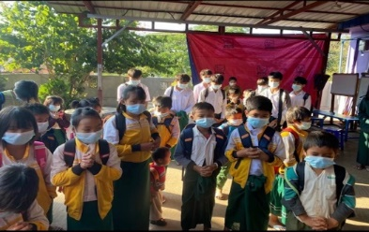
- 緬北貴概聖光學校即將在今年三月重開高中部，需要許多資源與準備。請為校長的學校管理、老師們的備課、學生們的學習情緒與態度，以及校務運作代禱，求主預備。

- 緬甸除了疫情、政治不穩定，學校的老師也是由軍政府安排。這些老師只會要求學生死背功課。因為學習壓力大，許多學生不願繼續學習。請記念 ｢希望之家｣ 孩子們的學習，求主保守。

- 緬甸因詐騙集團盛行，吸收年輕人做不法的事情，以高薪曚騙年輕人至博彩公司上班，以致許多年輕人初中畢業後，就停止升學，荒廢人生。甚至有些基督徒也為了賺更多錢而受騙。現今的世代邪惡，求主拯救！

- 緬甸疫情越加嚴重。請切切記念
連接秋季「觸動」中文電子版:
https://golovefoundation.org/main/wp-content/uploads/2022/01/NL_Fall-2021-C-v3-1-1.pdf

Praise and Prayer Requests

“In everything I did, I showed you that by this kind of hard work we must help the weak, remembering the words the Lord Jesus himself said: ‘It is more blessed to give than to receive.’ ” Acts 20:35

Praise:
- Starting in February, Go and Love is having a new staff, Minister Chen, joining in. He will assist Betty Chou, our president, with sharing GAL ministries among churches, conveying our vision and mission.

- Our president shared the message of “Let the blessings spread” to the Chinese churches in the Bay Area during the Lunar New Year time period. May this encourage fellow Christians to share the blessings we have in Christ, so that others will also receive this blessing from God.

Prayers:
- Here are 25 teachers who have signed up for the teachers training in North Myanmar from Feb 7-25. Please remember Teacher Gao who is preparing and conducting the training, as well as the attendees’ learning and attitude.

- The high school division at Kutkai Holy Light Christian School in North Myanmar will reopen this March and needs lots of resources and preparations. Please pray for the principal’s school management, teachers’ lesson preparation, students’ learning spirit and attitude, and the school operations. May the Lord provide.

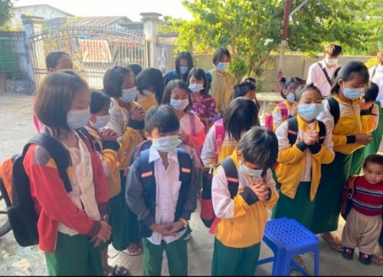
- In addition to the pandemic and political instability in Myanmar, all the teachers in schools are arranged by the military government. These teachers only demand the students to memorize all their homework. As a result, many students are reluctant to continue their studies because of the great pressure in studying. Please remember the Home of Hope children’s learning in your prayer. May the Lord protect them.

- Fraud organizations are very common in Myanmar. Many young people are lured into illegal activities. Gambling companies offer high salaries to attract young people to work for them. As a result, many stop going to school and waste their lives after graduating from junior high. Even some Christians fall into this trap in order to make more money. May the Lord rescue this present wicked age!

Link to Fall issue of Go and Love newsletter Touching Lives:
https://golovefoundation.org/main/wp-content/uploads/2022/01/NL_Fall-2021-E-v3-1.pdf

With Love,

Betty Chou and the Go and Love Foundation

