四月份感恩與代求
得著能力與為主見證
「但聖靈降臨在你們身上，你們就必得著能力，並要在耶路撒冷、猶太全地，和撒馬利亞，直到地極，作我的見證。｣ 使徒行傳 1:8

感恩
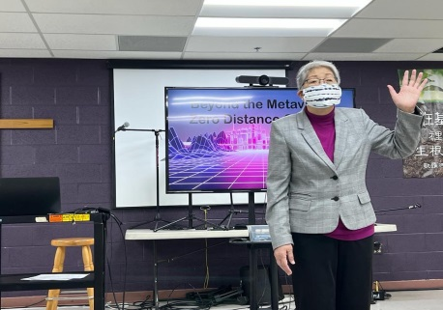
- 會長與同工在三月中旬向馬利蘭中華聖經教會及其分堂傳遞 ｢超越元宇宙的零距離接觸｣ 的信息，分享 ｢傳仁｣ 過去兩年如何藉著高科技，以虛擬的方式完成實質工作，以及如何在時差中達到零距離的事工果效。分享後，這些教會受到很大的激勵，並以實際行動參與作為回應。

- ｢傳仁｣已陸續拜訪灣區教會的牧者。透過與他們面對面的接觸以便建立關係，並傳遞｢傳仁｣在緬甸教育事工的｢築夢工程｣。目前已有幾位弟兄姊妹向｢傳仁｣表達願意加入師資團隊成為義工。

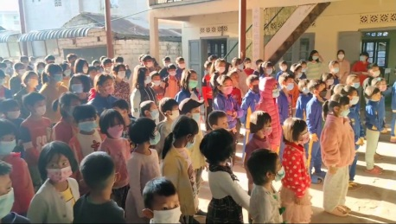
- 感謝神，緬北貴概聖光學校小學部與高中部已在3/28日開學，初中部在4/4日開學，貴概聖光學校已有227位學生報名上課。

代求
- 緬北尚有60多間基督教學校缺乏老師，請繼續為所需要儲備的師資代求。為遠距離教學與實體課堂的配置、為老師們的備課和學生們的學習情緒與態度，以及為校務管理與運作代禱，求主預備。

- 計劃每月底舉行老師教學經驗分享交流會，藉此能使授課更上一層樓。求主賜福帶領各位老師，加增他/她們的信心去克服教學上的難處。

- 繼續為｢傳仁｣與各教會建立關係，傳遞｢傳仁｣在緬甸教育事工的｢築夢工程｣、師資儲備與師資培訓禱告，求主開路。

- ｢傳仁｣繼續推動傳仁基金會的同工建造，成立不同小組，藉聖經學習、彼此代禱、關懷鼓勵、事奉分享、門徒訓練等建立更深的關係。求主深化同工建造。

- 緬甸疫情仍然緊張，政治仍不穩定，｢希望之家｣的中文學校雖然已經開學，但作息很緊湊，請為 ｢希望之家｣ 孩子們的學習禱告，求主賜恩。其次當地政府因戰事，在鄉村找壯丁參軍，也為曹傳道與青年男性安全代禱，求主看顧保守。

Praise and Prayer Requests

Receiving Strength and Witnessing for the Lord

“But you will receive power when the Holy Spirit comes on you; and you will be my witnesses in Jerusalem, and in all Judea and Samaria, and to the ends of the earth.” Acts 1:8

Praise:
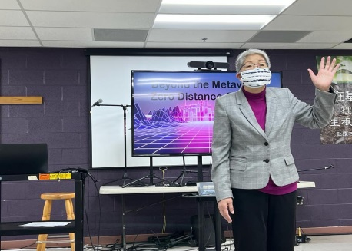
- Betty, our president, and Go and Love staff went to Maryland in mid-March, sharing the message of “Beyond the Metaverse, Zero Distance Contact” with different congregations at the Chinese Bible Church of Maryland. They shared how, over the past two years, GAL was able to accomplish actual ministry work in virtual means using high-tech and how to achieve direct contact despite time zone differences. After the sharing, these churches were greatly motivated and responded in actual participation and action.

- GAL has been meeting with church leaders in the Bay Area. Through meeting with them in person, we build relationships and convey the GAL educational ministry of “Dream Building Projects” in Myanmar. There have been several fellow brothers and sisters who have expressed their willingness in volunteering and becoming part of the teacher resource team.

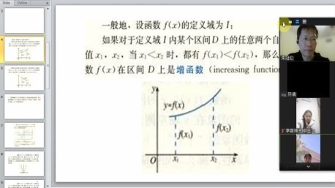
- Thank God that school started on 3/28 for the elementary and high school divisions and on 4/4 for the junior high division at Kutkai Holy Light Christian School in North Myanmar. Currently, there are 227 students registered.

Prayers:
- In North Myanmar, there are still over 60 Christian schools which lack of teachers. Please continue to pray for this need. Pray for the configuration of distant learning and physical classrooms, teachers’ lesson preparation, students’ learning spirit and attitude, as well as school administration, management, and operations. May the Lord provide.

- There is a plan to hold a teacher sharing meeting at the end of each month to support teachers as they enhance their teaching skills through mutual sharing and communication. May the Lord bless and guide the teachers as they overcome their challenges and increase their confidence toward teaching.

- Continue to pray as GAL builds relationships with churches, sharing the GAL educational ministry of “Dream Building Projects”, building a pool of potential teachers and providing teachers training. Pray that the Lord will pave the way.

- GAL will continue to further staff edification, establishing different small groups and building deeper relationships through Bible studies, prayer support, care and encouragement, ministry sharing, and discipleship training. Please pray for the staff build up and deepening in relationships.

- The pandemic and political situation in Myanmar continue to be tense and unstable. The Chinese school at the Home of Hope has started and runs a tight schedule daily. Please pray for the children’s learning at the Home of Hope. May the Lord’s grace be upon them. Furthermore, because of the war, the local government is searching for strong men to join the army from villages. Please pray for Minister Cao and the young men’s safety and for God’s protection.

With Love,

Betty Chou and the Go and Love Foundation

